Use-Case Realization Report
Add Lesson

Issue <3.0>
Revision History
Date | Issue | Description | Author
01/08/09 | 1.0 | Initial Version | Haiyang
16/09/09 | 2.0 | Revised after Peer Review | Haiyang
12/10/09 | 3.0 | Modified based on open source review | Rajendran Kumaraguru

Table of Contents
1. Brief Description 4
2. Flow of Events 4
2.1 Standard Flow 4
2.2 Exception Flow 4
3. Interaction Diagrams 4
3.1 Collaboration Diagram for Add Lesson 4
4. Participating Objects 5
5. Class Diagrams 5
5.1 Class Diagram for Add Lesson 5
6. Derived Requirements 6

Use-Case Realization Report
Add Lesson

Brief Description
Upon successful creation of the creation, lesson will be created in order to upload the content for each lesson. This would be first step while adding the lesson. Adding the lesson can be done only thru portal administrator. Portal admin should have necessary roles for creating the lessons for each company.

Flow of Events

Standard Flow
- Portal Admin log into the system, and go to Lesson Admin Page.
- By clicking the “btnAdd_Click” button, the CMS Site Maintenance will be called in order to create the site for the registered company.
- Company Details will be loaded into the system.
- Site Information will be fetched.
- Company information will be fetched from ACS,
- Validate fields will be validating the data field values before proceeding to check the duplicate folder check.
- Duplicate Folder will be checked before creating the site
- Duplicate site will be checked if there is any site which is already created.
- Site will be created
- Based on the above conditions the module master will be updated with newly created the site.
- New folder will be crated for the new site.
- Once the site is successfully created then message will be shown to portal admin for the success of the creation.

Exception Flow
- If there is a folder already exist system will throw the exception duplicate folder.
- If the site is already exist then system will throw the exception duplicate site.

Interaction Diagrams

Collaboration Diagram for Add Lesson
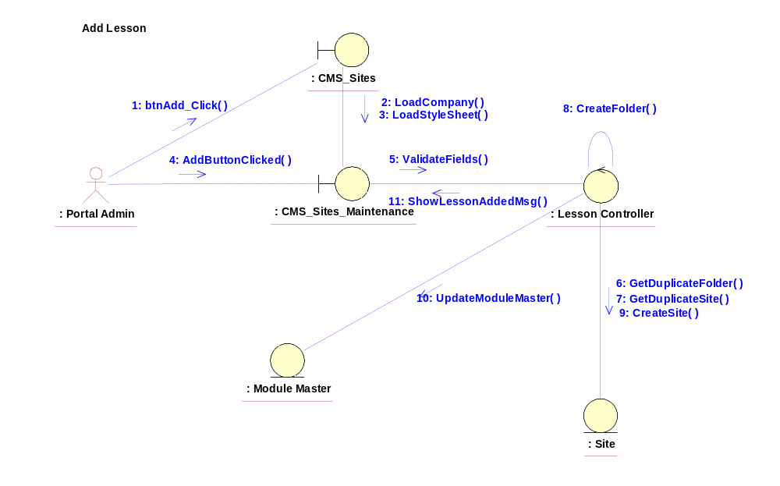

Participating Objects
: CMS_Sites
This entity is the lesson object, it belongs to JMD.
: CMS_Sites_Maintenance
This is the page for adding, deleting, modifying lessons.
: Lesson Controller
This is the controller to upload, add, delete and modify lessons.
: Update Module Master
Creates modules for the added lesson.
: Site
Adding the site upon creation of the folder.

Class Diagrams

Class Diagram for Add Lesson
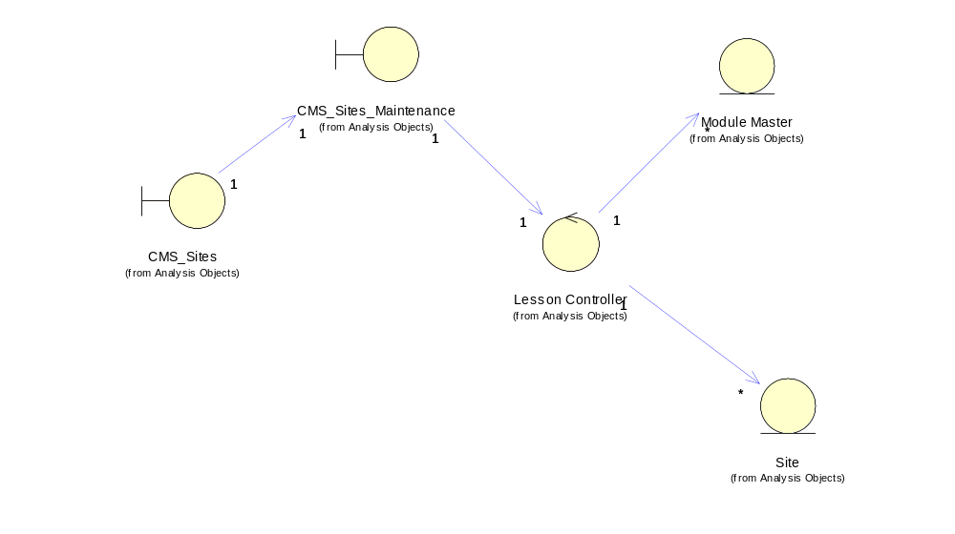

Derived Requirements
[enter the derived requirements here]

